**DATA GATEWAYS** & **DATA REFRESH**

**POWER BI GATEWAYS** [ALSO CALLED AS "DATA GATEWAYS"] : AN APPLICATION THAT NEEDS TO BE INSTALLED IN THE COMPUTER WHERE THE ACTUAL DATA SOURCE RESIDES / ACCESSIBLE.

USED FOR SCHEDULED DATA REFRESH BETWEEN THE DATA SOURCE TO POWER BI CLOUD.

REQUIREMENTS: 64 BIT WINDOWS OS, ANY PROCESSOR.

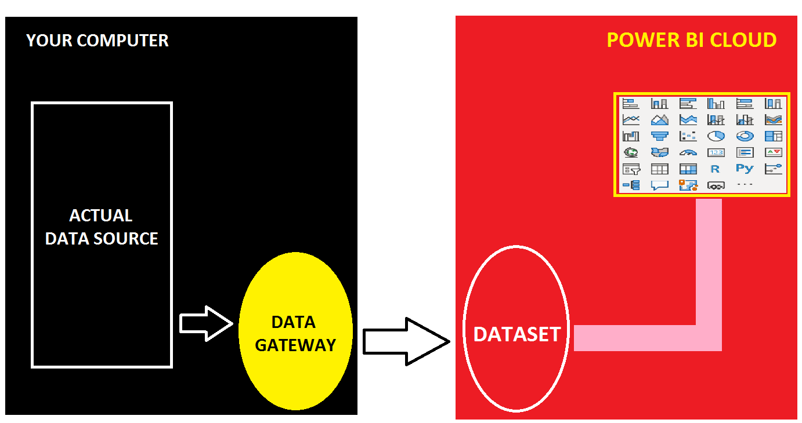

**STEP 1:** IDENTIFY THE SOURCE OF POWER BI REPORT IN YOUR COMPUTER (EX: EXCEL FILE in C DRIVE).

DESIGN REPORT IN POWER BI DESKTOP > PUBLISH TO CLOUD.

**STEP 2:** DOWNLOAD DATA GATEWAY FROM : <https://powerbi.microsoft.com/en-us/gateway/>

INSTALL > SELECT "**STANDARD MODE**" GATEWAY [MULTI USER CONNECTIONS].

WHEN PROMPTED, **SIGN IN** TO POWER BI CLOUD.

WHEN PROMPTED, **REGISTER** THE GATEWAY ON YOUR COMPUTER > SPECIFY **GATEWAY NAME** & PASSWORD > CONFIGURE. GATEWAY RUNS WITH "**NT SERVICE\PBIEgwService**" > CLOSE.

**STEP 3**: FROM POWER BI CLOUD > TOP : RIGHT > SETTINGS > MANAGE GATEWAYS > SELECT ABOVE CREATED GATEWAY > ADD DATA SOURCE > SOURCE CONNECTION DETAILS [FILE PATH AND FILE NAME, EXTENSION], ACCES DETAILS [USER NAME, PASSWORD] > TEST CONNECTION.

**STEP 4**: FROM POWER BI CLOUD > WORKSPACE > DATASET > SETTINGS > GATEWAY CONNECTION > SELECT REQUIRED GATEWAY AND MAP THE REQUIRED SOURCE CONNECTION > CLICK @ APPLY.

SCROLL DOWN > SCHEDULE REFRESH : ON > DEFINE THE SCHEDULE.

SENT NOTIFICATION EMAIL IF REFRESH FAILS > CLICK @ APPLY.

**STEP 5**: TO TEST THE REFRESH: FROM POWER BI CLOUD > WORKSPACE > DATASET : ACTIONS > REFRESH. THEN FROM POWER BI CLOUD > WORKSPACE > REPORT : REFRESH